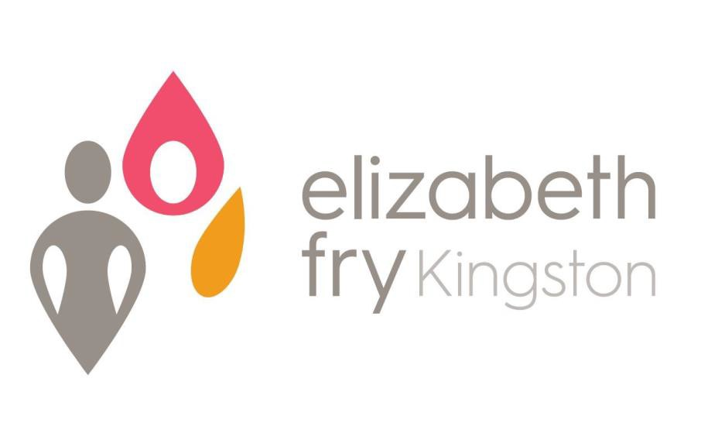
Annual Report 2018-2019

Elizabeth Fry Kingston is a non-profit organization that serves women in conflict with the law and women at risk due to financial and social barriers;
We advocate for progressive legislative and administrative reform of the Criminal Justice System and other institutions;
We educate about issues that disadvantage women in the justice system;
We encourage public participation in all aspects of justice for women

STAFF OF ELIZABETH FRY KINGSTON
November 2019

Executive Director
Kathryn Londry
Project Lead, C.A.R.E Program
Judi Burrill
Mental Health Support Worker
Amanda Lane
Financial Administrator
Julie Spencer
Office Administrator
Cassandra Gillespie
Community Outreach Worker
Christina Moeys
Community Outreach Worker/ Programs Co-ordinator (WE Hub)
Rebecca McLauchlan
Executive Assistant
Tabatha Maloney
Grants Co-ordinator
Stacey Alarie
Residential Case Managers
Paola Gongora
Alyssa Henry
Alicia Howell
Residential Night/Weekend Staff
Amberlee Burns
Joy Harrison
Helen Wood

ORGANIZATIONAL CHART
Board Committees & Representation

Executive
Finance
Personnel
Policies, Procedures, and Governance
Admissions
Bursary

Membership
Board of Directors
Executive Director is Ex Officio Board Member
Executive Committee

Executive Director

C.A.R.E.
Program
Project Lead
Program Co-ordinator
WE Hub
(0.5)
Mental Health Support Worker
CRF
Case Managers
(3)
Programming Services

- Kaye Healey Homes & Supportive Non-Profit Housing Program
- Homelessness Prevention
- Women Empowered (WE) Hub
- Community Outreach & Education
- C.A.R.E. (Court Accompaniment, Referral & Education) Program
- Reintegration Support
- Residential Program (CRF)
- Institutional Visitation
- Mental Health Support
- Community Kitchen / Garden
Office Administrator
Community Outreach Worker
(1.5)
Students
Volunteers
Relief Residential Staff

ELIZABETH FRY KINGSTON
Statement of Revenue and Expenses
For Year Ending March 31, 2019
Revenue | 2018/2019
City of Kingston | $ 451,813.00
Residential Contracts | $ 398,184.00
Other Contracts | $ 97,596.00
Rental Income | $ 180,487.00
United Way KFLA | $ 36,562.00
Detweiler Estate | $ 35,820.00
OLG Revenue | $ 26,002.00
Donations and Fundraising | $ 10,227.00
Grants | $ 36,345.00
Other | $ 1,686.00
Total | $ 1,274,722.00
Expenses | 2018/2019
Salaries & Benefits | $ 560,058.00
Interest & Taxes | $ 117,583.00
Utilities | $ 98,249.00
Repairs & Maintenance | $ 125,260.00
Office & Telecommunications | $ 36,906.00
Client & Program Expenses | $ 15,999.00
Rental Expense | $ 12,555.00
Training & Meeting Expense | $ 3,032.00
Professional Fees | $ 24,539.00
Travel | $ 12,984.00
Reserve Fund Expenditures | $ 24,742.00
Insurance | $ 18,967.00
Hub Renovations | $ 21,959.00
Bad Debts | $ 1,550.00
Total | $ 1,074,383.00
Excess Revenue over Expenses | $ 200,339.00
Forgivable Loan Interest | $ -10,353.00
Loan Forgiveness | $ 10,353.00
Amortization of Deferred Contributions | $ 8,518.00
Amortization of Capital Assets | $ -143,450.00
Subsidy Adjustment for Prior Year | $ -11,816.00
Balance | $ 53,591.00
STATEMENT OF REVENUE AND EXPENSES

♀SPECIAL THANKS & ACKNOWLEDGEMENTS♀
Funders, Donors and Supporters of Elizabeth Fry

FUNDERS
City of Kingston – Community & Family Services
Correctional Service Canada
Ministry of Community Safety & Correctional Services
United Way of KFL&A
The Law Foundation of Ontario
Detweiler Estate
Human Resources Development Canada (HRDC)
Community Spirit Bingo

SUPPORTERS
Canadian Association of Elizabeth Fry Societies
Kingston Peer Support
P4W Women’s Collective
Partners in Mission Food Bank
Queen’s University Pro Bono Law Students
ReStart
Rustle Church
St. Lawrence College
The Elm Cafe
Trillium College
Value Village
WINMAR
Women’s Interfaith Group

DONORS
Allan Gregory
Canadian Tire
Community Foundation- Regina Rosen Food First Fund
Elizabeth Macdonald
Food Rescue
Four Winds Presbyterial
Glenn Little
Grants No Frills
Home Depot
Impact Church
Jennifer Tindale
Korean Church
Loving Hands
Loving Spoonful
Loyalist Community Sharing Centre
MotoSport Plus
Queen’s Smith School of Business Charity Gala Team
Queen’s University Faculty of Health Sciences
Providence Care Hospital
Rainbow Providence Associates
Riverside United Church Women
Robert McIntyre
Shoebox Project
Socks Kingston
St. Thomas More Catholic School
TC Infrastructure Management Inc.
Trinity U.C.W. Elginburg
Women’s Inter-Church Council of Canada

♀QUEEN’S SMITH SCHOOL OF BUSINESS CHARITY GALA♀

SPONSORS

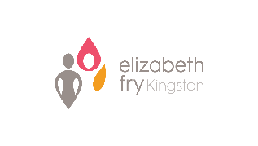
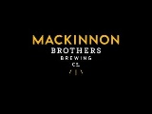

GUEST SPEAKER

Kingston Chief of Police
Antje McNeely

SILENT AUCTION DONATIONS

Absolutely Polished Cleaning Services
Ben Fickling
Blaine Kovacik
BluMartini
Car Medics
doTERRA
E & J Gallo Winery Canada, Ltd
Eric Opoku
Frontenac Cycle Sport
Immerse Spa Kingston
Kingston 1000 Islands Cruises & Trolleys
Kingston Nissan
Leon’s Centre
MacDonald’s
Mackinnon Brothers Brewing Company
Maple Leaf Sports and Entertainment (MLSE)
Megan Lukan -Authentically Bold
Novel Idea
Painting by Eric Opoku
Painting by Prateek Bansal
Popeye’s Supplements Kingston
Prateek Bansal
Red House
Royal Angkor
St. Louis Bar & Grill
Sterling
Symphony Spa & Yoga
The Grand Theatre Kingston
Union Kitchen + Cocktails
Wendy’s

127 Charles Street
Kingston, ON
K7K 1V8

Telephone: 613-544-1744
Toll Free Line: 1-888-560-3379
Fax: 613-544-0676
Email: info@efykingston.com

www.efrykingston.ca

JOIN US!!

www.twitter.com/efrykingston www.facebook.com/efrykingston

The views contained in this document do not necessarily reflect those of the Federal or Ontario Governments or our funder

